Read me for soapui project

File🡪import packed project

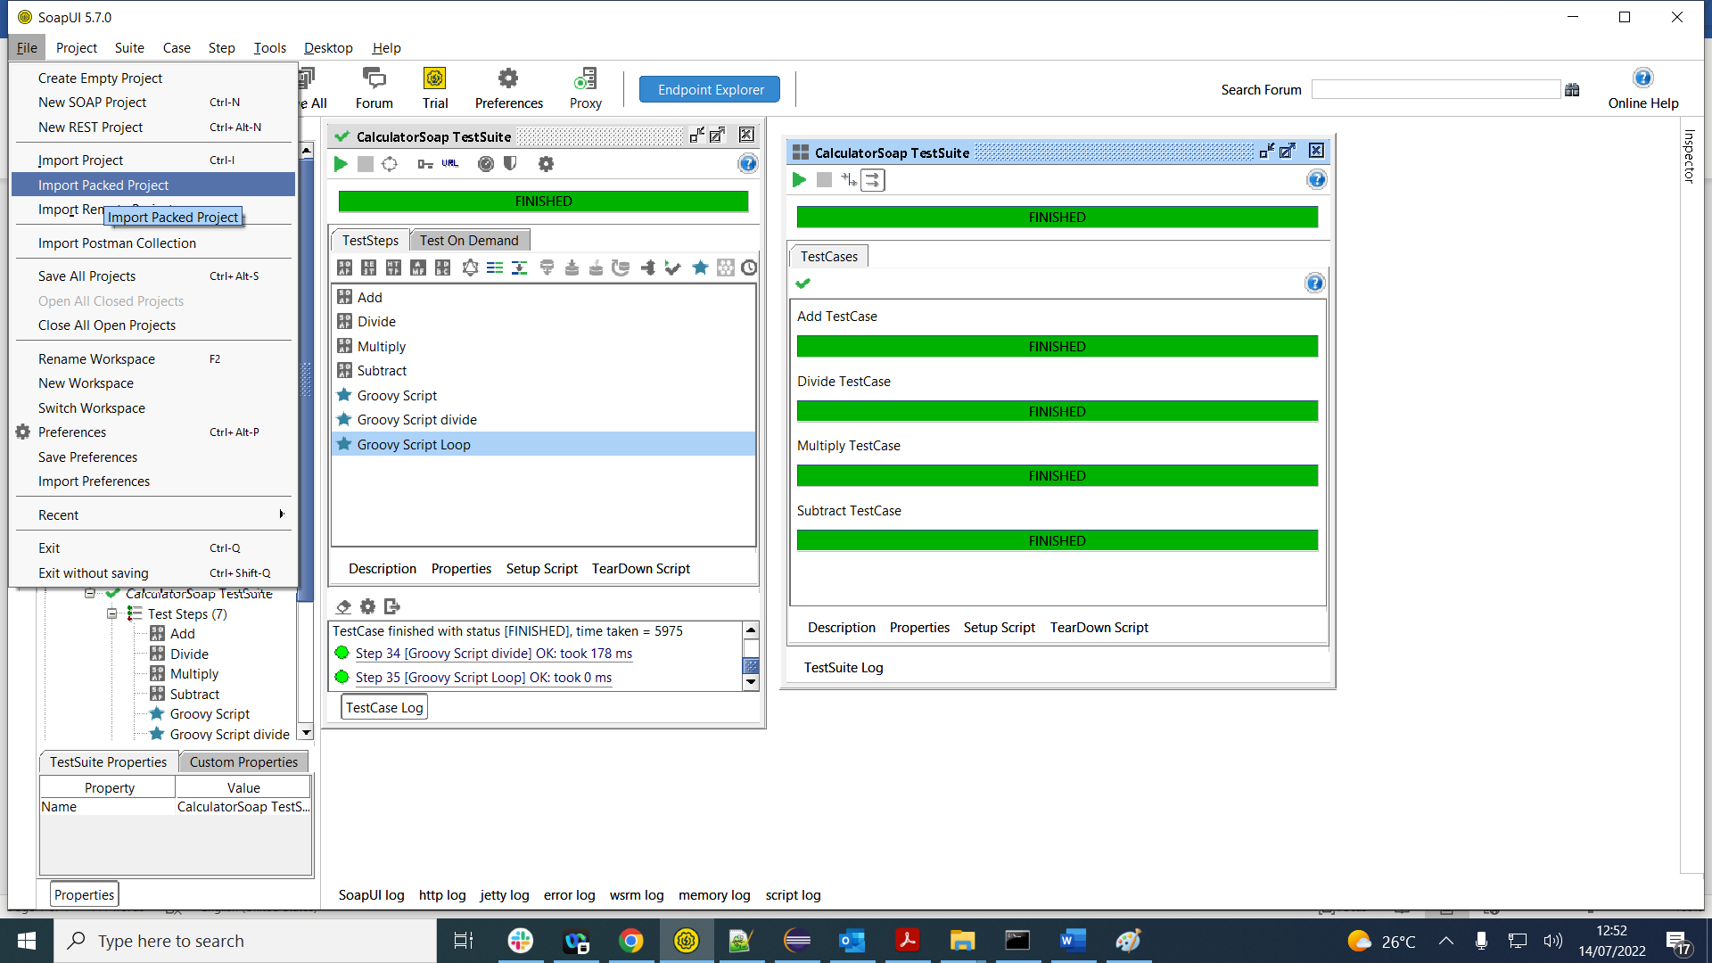

Add the zip file then, the testcase test suite ll be available from the git to soap tool

